GQM+Strategies
Use-Case-Realization Specification: <Use-Case Name>View Measurement Data

Version 1.1

Revision History
Date | Version | Description | Author
15/12/2013 | 1.0 | Initial Version | Tiziano Campili, Marco Ferrari
16/01/2014 | 1.1 | First Review | Tiziano Campili, Marco Ferrari

Table of Contents
1. Introduction 4
1.1 Purpose 4
1.2 Scope 4
1.3 Definitions, Acronyms, and Abbreviations 4
1.4 References 4
1.5 Overview 4
2. Class Diagrams 4
3. Sequence Diagrams 7

Use-Case-Realization Specification: <Use-Case Name>View Measurement Data

Introduction

Purpose

This document represents how the View Measurement Data use case will be implemented in terms of collaborating objects.

Scope

This document describe the realization specification on View Measurement Data use case.

Definitions, Acronyms, and Abbreviations

Refer to Glossary Document.

References

- Glossary
- Use Case – View Measurement Data

Overview

This document contains the Use Case Create Metric class diagram and collaboration diagrams.

Class Diagrams

The figure below shows an analysis class diagram for the realization of the View Measurement Data use case. Notice the use of model-view-control stereotypes to represent analysis classes, and the use of data access object (DAO). The DAO is an object that provides an abstract interface to some type of database or other persistence mechanism by mapping calls to the persistence layer, DAOs provide some specific data operations without exposing details of the database. In conclusion, note the use of the pattern facade, through the use of business object facade. The Facade is an object that provides a simplified interface to a larger body of code, such as a class library or in our case one or more Data Access Objects.

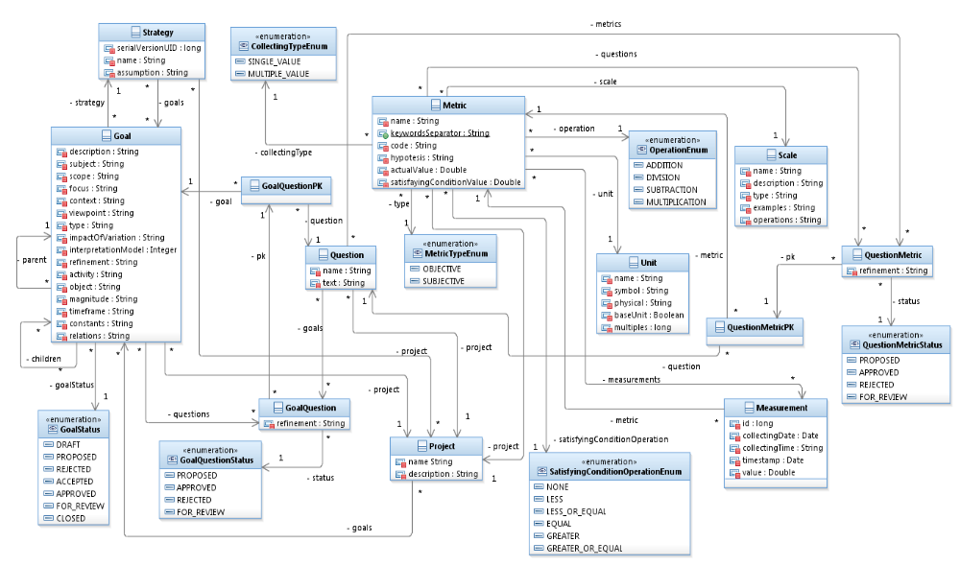
Figura 1. Model Class Diagram

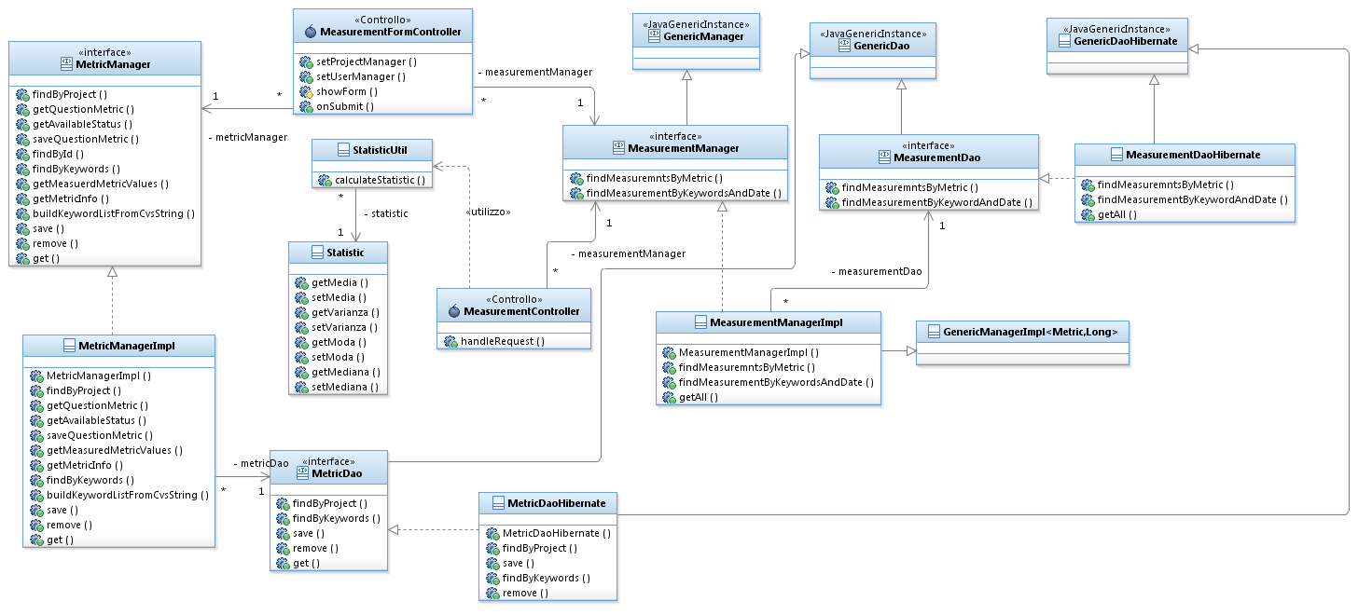
Figura 2: View Measurement Data Class Diagram

Sequence Diagrams
This section shows the interaction diagrams depicting its participating objects and their interactions.
There are two types of interaction diagrams: sequence diagrams and communication diagrams. They express similar information, but show it in different ways. Sequence diagrams show the explicit sequence of messages and are better when it is important to visualize the time ordering of messages, whereas communication diagrams show the communication links between objects and are better for understanding all of the effects on a given object and for algorithm design.

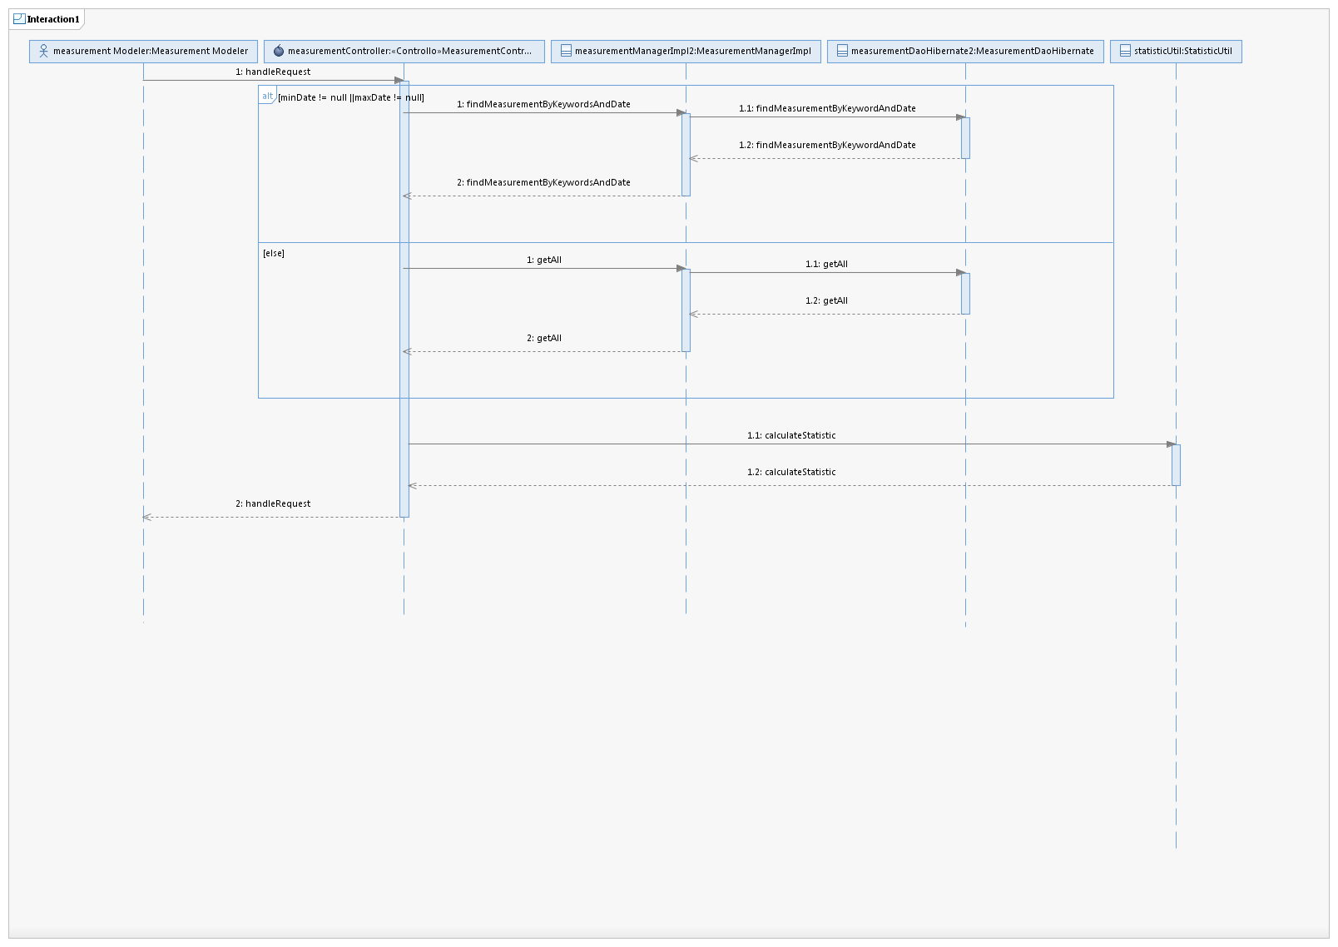
Figura 3: View Measurement Data Sequence Diagram

